APOD/NASA WEBPAGE
Student’s name
Course
Instructor
Date of submission

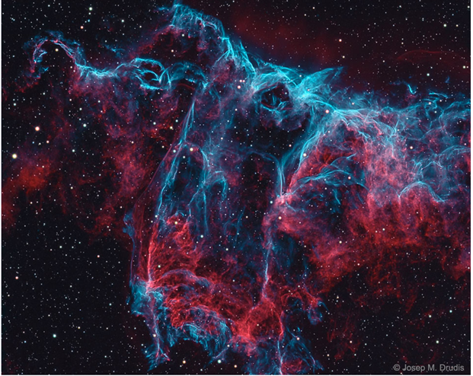
I chose this picture because there is a sign of a bat depicting the haunting of the cosmic close-up of the eastern Veil Nebula.
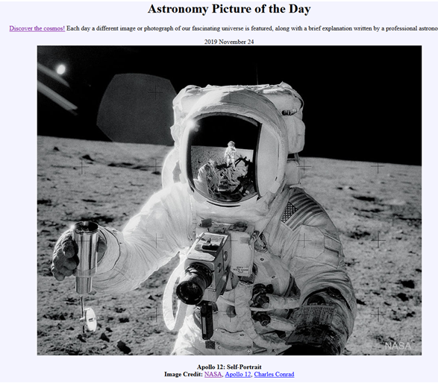
It happened fifty years ago when Charles Pete Conrad Apollo 12 an astronaut-photographer took this photo of Alan Bean collecting lunar soil activities on Ocean Procellarum.
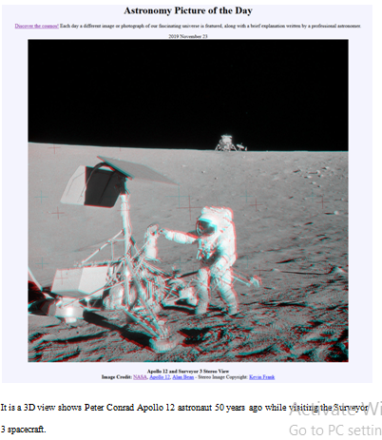
It is a 3D view shows Peter Conrad Apollo 12 astronaut 50 years ago while visiting the Surveyor 3 spacecraft.
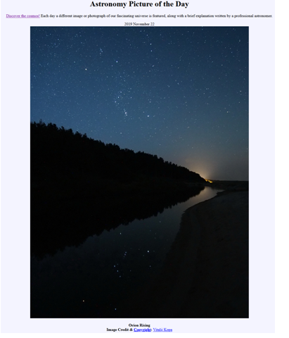
This depicts how winter comes to plane Earth’s northern hemisphere.
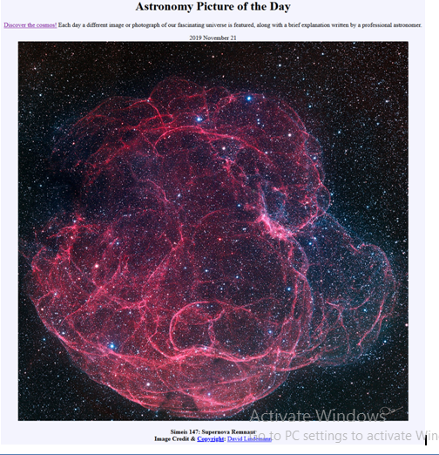
This picture shows that how easy it is to get lost while make a follow up of the intricate looping filaments in the above supernova remnant detailed image Simeis 147.
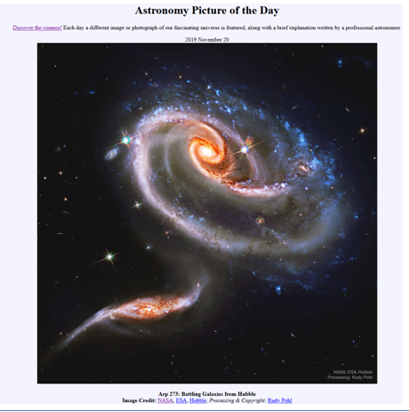
The above explains all about what happens with the spiral galaxies.
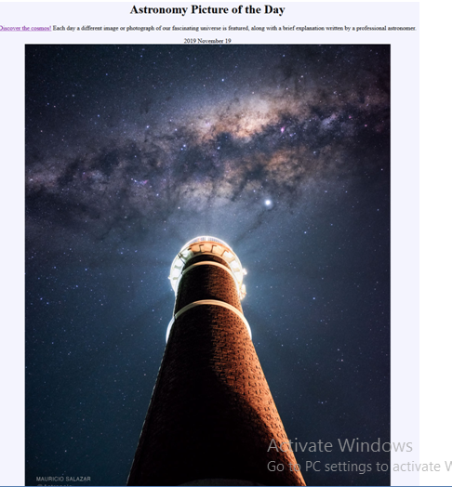
The picture above shows how possible a lighthouse can illuminate a galaxy when the images are planned in a way that excludes direct light from the famous lighthouse.
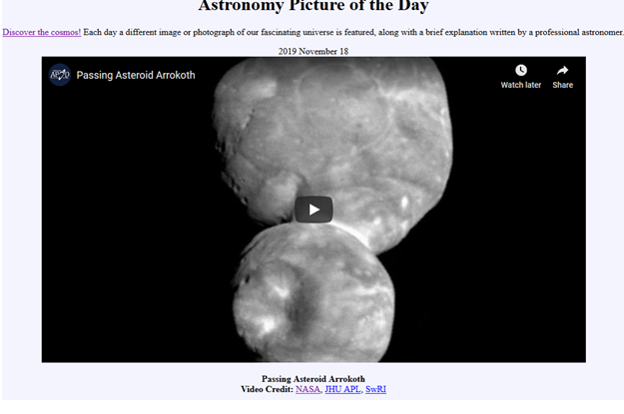
It shows how it looks after passing asteroid Arrokoth.
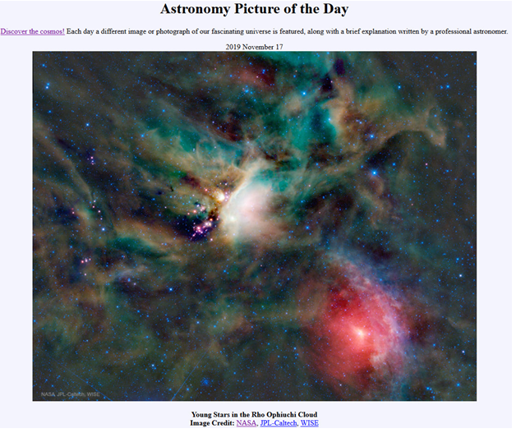
It shows how stars form with the help of embedded newborn stars in infrared wavelengths, tantalized false-color composition of dust clouds and the wide-field Infrared Survey Explorer.
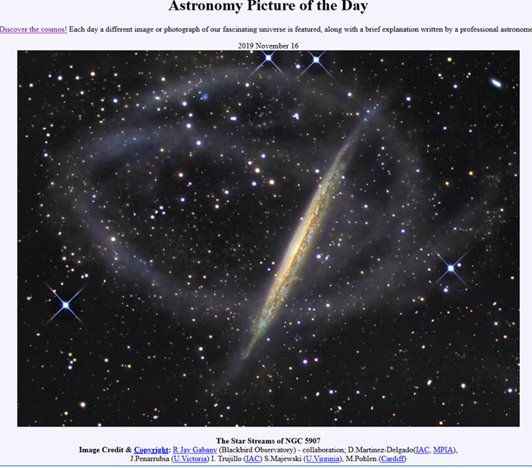
It shows how grand tidal streams of stars surround the galaxy NGC 5907.
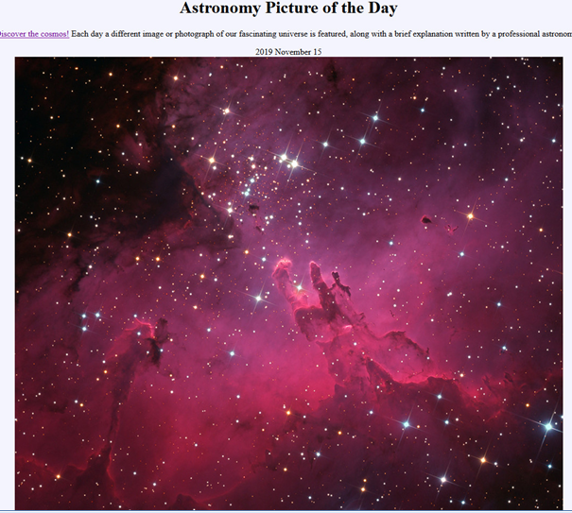
It shows a cluster of stars about two million years being surrounded by glowing gas and natal clouds of dust.
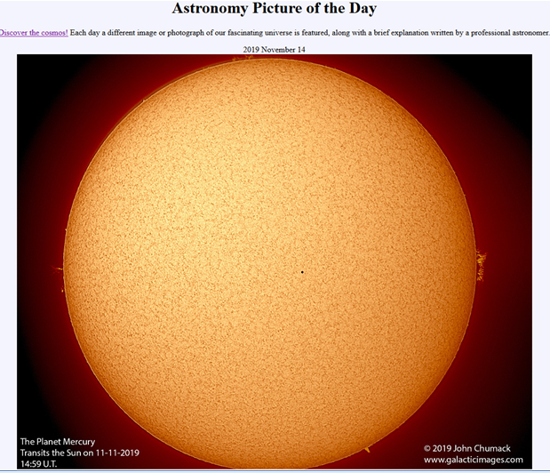
This picture shows the transit of mercury and the quite of Sun where it experiences a minimum in its 11 year cycle of activity.
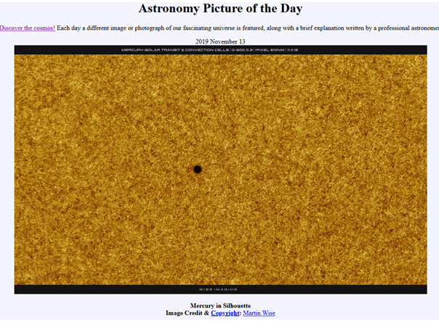
I chose it because it shows solar close up planet Mercury as a small, dark, round spot.
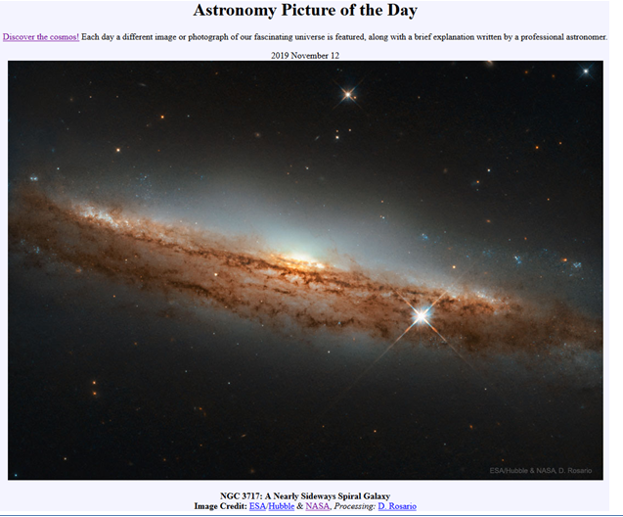
It shows some of the spiral galaxies as there seen nearly sideways.
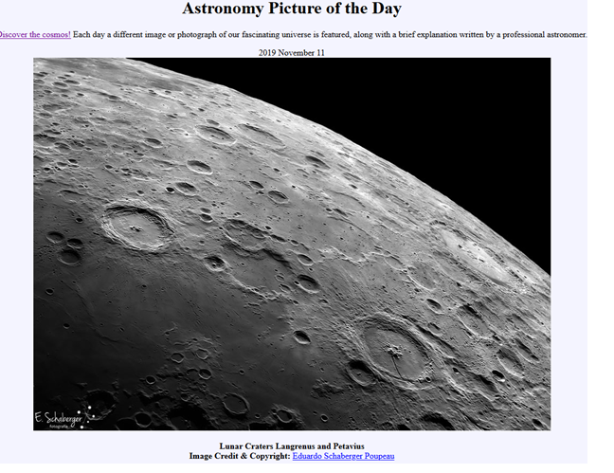
It shows how the history of the Moon is written partly in its craters.
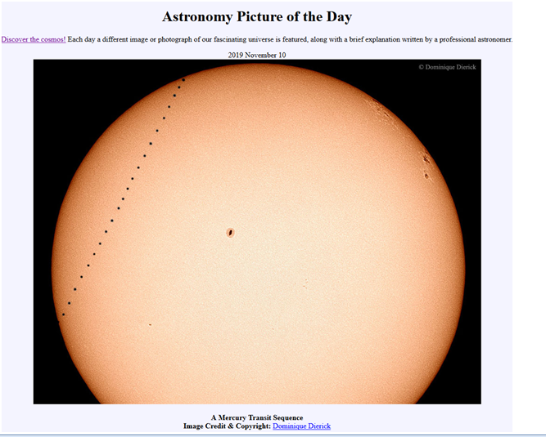
This picture shows how a Mercury transit occurs whereby Mercury crosses the face of the Sun as observed while from Earth.
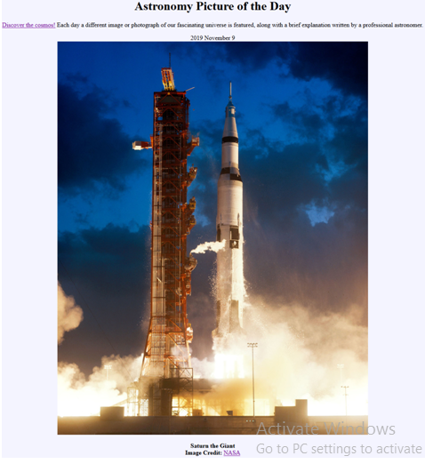
It shows the first attempt of landing astronauts in the Moon using Saturn V rocket as earlier announced by John Kennedy.
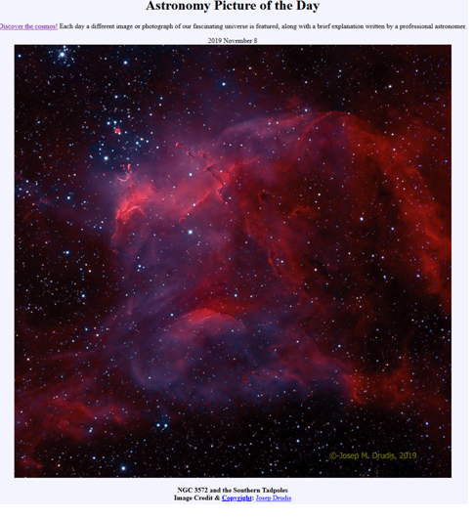
It shows the cosmic skyscape featuring dark dust clouds and glowing gas alongside the NGC 3572 young stars.

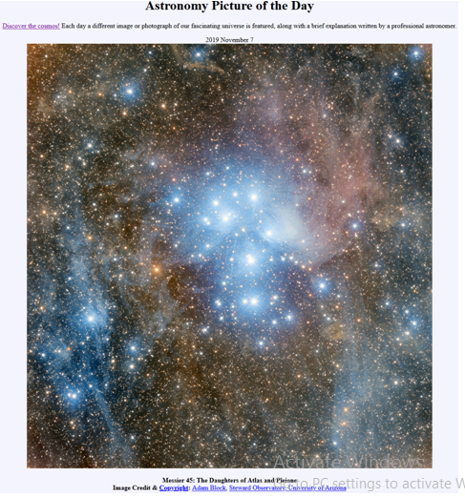
It shows the daughters of Pleione and Atlas.
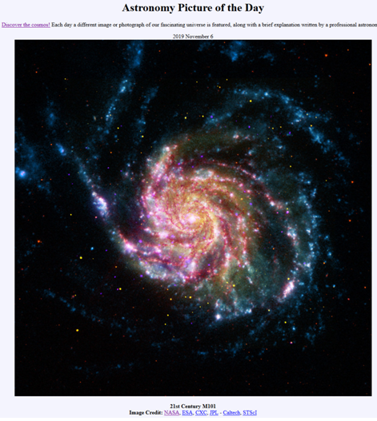
It shows one of the last entries done in the 21st century in Charles Messier’s famous catalog where M101 is not one of the least.

